FEAS Newport
Standard Operation Procedures Manual
Title: Standard Operation Procedure for the preparation of eel otoliths for image analysis

SOP No.:  SAMPLE | Revision No.:  00 SAMPLE | Issue Date: 00-00-00 | Page 1 of 1

1.Purpose and Scope

This procedure provides a method for processing eel otoliths and the assessing the age of the eel by counting the annuli highlighted as a result of the burning process using a dissecting microscope and image software.

(Christensen, 1964)first reported that eel otoliths could be successfully prepared by burning in a flame and cracking to reveal the annuli on the broken face of the otolith. The preparation of eel otoliths was described by Moriarty (1973 ) and developed by Hu and Todd (1981) with a more permanent mount made by mounting the otolith in silicone sealant against a glass slide. The otolith is burnt either before or after cracking. Traditional burning and cracking was used but with the advent of better digital imaging processes, the ICES workshop of 2009 recommended replacing the burning and cracking method by first cutting and then burning the otolith. The cutting and burning method is described here and the traditional technique is described as a variation. This procedure is taken from (ICES, 2011).

2.Responsibility

2.1 It is the responsibility of the designated technician to ensure that all staff are trained, authorised and implement this procedure.

2.2 It is the responsibility of all employees to comply with this SOP and to notify the designated technician immediately if difficulties are experienced.

2.3 It is the responsibility of the designated technician to ensure that all relevant equipment is calibrated/ verified according to the defined schedule.

3.Procedure

3.1: Equipment

- Glass Microscope Slides
- Fine Forceps
- Fine pointers
- Heavy Scalpel (with insulated handle for burning)
- Scalpel (with sharp blades for cutting)
- Bunsen Burner/Spirit Burner
- Slide container box
- Syringe
- Clear silicone sealant for glazing (Panabond is best – test new ones to avoid clouding on cure)
- Light box or light projector for illuminating the nucleus of the otolith when cutting
- Safety glasses
- Clear sellotape

3.2: Cutting and burning

Eel otoliths, once removed from fish heads, should be cleaned by rubbing gently and placed into your storage medium (scale envelopes, unsealed eppendorf tubes etc.) and left in a warm dry place for several days to dry.

Otoliths are removed from the envelope etc. using a fine forceps and placed on a glass microscope slide convex side down. The otoliths are then stuck to the slide with clear sellotape. A sharp scalpel is then used to cut the otoliths in half along the transverse axis, through the nucleus (Figure 1). Care must be taken to cut through the nucleus of the otolith. Illuminating the otolith from below, using a light box or modified projector, helps identify the nucleus (Figure 2).

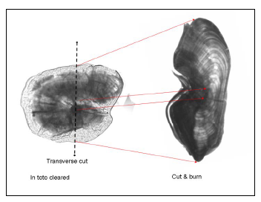

Figure 1: Otolith in traverse.
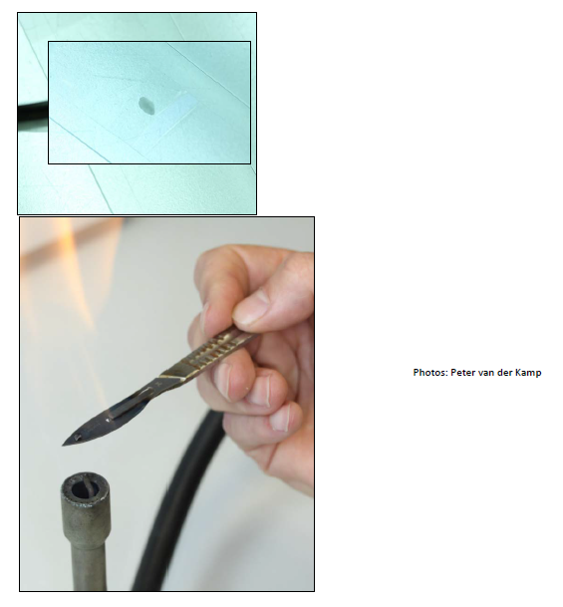
Figure 2: Cutting the otolith through the nucleus and burning in a Bunsen Flame.

After cutting, the otolith halves are placed on a scalpel blade and placed into the upper blue part of a moderate Bunsen flame for up to 30-60 seconds, by which time they have darkened to a slate grey colour (Figure 2). This will follow initial darkening from light brown to black. It is important that the flame is not too hot as incomplete, or patchy, incineration can occur.

[NOTE: Wear safety glasses when burning otoliths]

The otolith is very delicate after being burnt and must be handled with care. The otolith halves are picked up using a pointer, which has been dipped in a small amount of the sealant and gently mounted in a small bead of silicone sealant that has been placed on a microscope slide, with the prepared reading surface pressed against the slide surface. The otolith should be slid sideways into the sealant in order to exclude any trapped air bubbles. By carefully turning the microscope slide it can be checked whether the otolith is placed the right way, if not some alterations to the mounting can be carefully made, but this needs to be done quickly before the silicone begins to cure. The silicone is left to set for approx. 45-60 minutes before a second bead of silicone sealant is placed on top of the first to seal in the otolith halves and make a permanent mount. The otoliths are read through the glass of the inverted slide (Figure 3) under a stereo microscope using reflected light under magnification between x20 and x50.

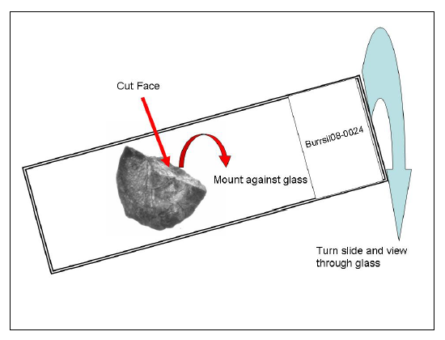
Figure 3: The cut face of the burnt otolith is mounted in silicone against the glass and the side is inverted for viewing under reflected light.

3.3: Age reading

Regardless of the plane of view, the reading transect begins from the centre of nucleus to the furthest edge of the otolith. The path of the transect is dependent upon the quality and characteristics of the otolith being aged, but recommendations are made to read along the proximal plane, in the case of burning and cracking, to intersect each annulus at its widest point.

Zero Band

The ageing of the eel for the continental phase, has traditionally commenced from the first clearly marked band outside the nucleus. This 'zero' band is assumed to be the beginning of continental growth in the eel, equivalent to the total length for the glass eel (Moriarty, 1983, Poole et al., 2004). The next annulus is considered to be the end of the first year of growth (Figure 4). For the determination of the continental age of the eel, counting of annuli begins after identification of the zero band, with the following annulus representing the first years winter band in the continental phase, a process considered in more detail within section 6.2 of the ICES WKAREA 2009 report, but has been summarized below:

- The 'zero band' is assumed to be the end of the oceanic/metamorphosis phase and the beginning of continental growth in the eel, equivalent to the total length for the glass eel, resulting in the next annulus to be considered as the end of the first year of growth.

- In the case of ambiguity in the identification of zero bands, the radius from the centre point of the nucleus to the assumed zero band proximity is on average 170μm for A. anguilla.

- Care must be taken to identify check marks which are often observed between the nucleus edge and the zero band, so to define the zero band with confidence.

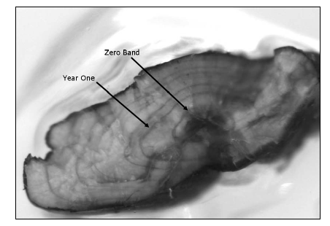
Figure 4: A burnt and cracked otolith (traverse plane) from A. anguilla showing the location of the zero band and first winter annulus.

Annulus identification

A year’s growth consists of both translucent (winter growth) and opaque (summer growth) zones. Accurate analysis requires a confident distinction to be made
between;

- Clearly visible as a bold growth check to be considered an annulus,

- In the case of burnt and cracked otoliths, the growth checks should be clear and continuous, at least down the inside edge of the otolith

- False annuli are usually of lesser strength to the annuli, are not continuous and/or merge with other checks.

- Eel growth is highly variable and therefore it is difficult to predict ‘normal’ patterns of annual growth to facilitate the identification of false annuli. Checks that appear too close to the neighbouring checks may be false annuli and should be treated with caution. For additional information see Graynoth (1999).

The counting of consecutive annuli will provide an estimation of age, provided that check marks are successfully identified and excluded from the final count. The distinction between annulus and check marks are defined as such in the glossary and discussed further in section 6.3 of ICES WKAREA 2009 report.

It is important, but difficult, to identify and discount the inclusion of false annular growth checks, often caused by stress associated with quarantine/marking and tagging of stocked glass eel, periods in aquaculture, or due to natural stresses and growth variability in the wild.

Otolith Reading Calendar

For both A. anguilla & A. rostrata the following recommendations are made:

- The age reference date is set as 1st of January.
- Age is estimated based on the counts of winter rings.
- The term ‘+’ growth can be used as an indication of additional growth but this should not confuse the calendar age of the eel.

For yellow eels, it is recommended that attention be drawn to the timing of capture and local conditions. Depending on the growing season of the capture location, the appearance of winter annuli on the otolith will vary. In the early part of the year the outer most winter annulus is generally not apparent until the summer growth begins in the New Year. This will vary between years and between locations. Therefore, an additional year should be added to these eels sampled early in the year after January 1st in order to account for this undifferentiated annulus from the outer margin of the otolith.

For silver eels, flexible interpretation in some local situations may be required. Silver eel traditionally migrate as an annual migration 'cohort'. This 'cohort' receives its age from the next January as the eels have completed their annual growth period and we assume a putative annulus on the outer margin of the otolith (e.g. silver eels migrating in October 2008 take their age from the January 2009).

In the Northern European region (e.g. Scandinavia) the silver eel run may cease prematurely due to cold temperatures in the winter months and recommence in the following spring, then both portions of the migration should be referenced to the January in the middle of the run. Similar delayed runs can occur due to low water and/or hydropower barriers that prevent migration.

3.4: Acquiring an Image using Image Pro Plus

- Turn on computer, microscope and camera.
- Open Image Pro Plus software.
- Place otolith to be examined under dissecting microscope.
- Click acquire video/Digital Capture-Preview.
- Click preview to bring up live image
- Click on Calc Auto Exp or alter exposure using manual exposure.
- Click Snap to take image.
- Before saving check calibration.
- Save image in the Tiff format (make sure that you have the image set at the right magnification).

3.5: Measuring Annuli

- Click Measure/Measure distances (Opens the Measurement dialog box)
- Click on start point and drag line to finish point, click to finish.
- Measurement will come up on the screen beside the line.
- Click Measure/Calliper (opens dialog box).
- Click options tab, check “Use spatial calibration” box is ticked.
- Click on line at top left (straight/freehand).
- Draw line on image by clicking and dragging. Release to end line.
- To measure increments, go to edge detectors and click on new.
- Select the Type: Derivative
- Click Valley and then click OK.
- Dark points are then highlighted e.g. annuli
- Check the selected lines are correct, lines can be added or deleted by using the “-“ button on the calliper dialog box.
- Click on the measurements in the tab in the Calliper dialog box.
- Click on measurement within this dialog box.
- Select Add -> Type -> Distances between Markers of an edge detector, click OK.
- Click on the Input/Output tab -> Destinations: Export Data/Target.
- Click Send Data
- Data is sent to an Excel File which automatically opens.

3.6: References

CHRISTENSEN, J. M. 1964. Burning of otoliths, a technique for age determination of soles and other fish. Journal du Conseil Permanent International pour l’Exploration de la Mer 29, 73-81.
HU, L. C. & TODD, P. R. 1981. An improved technique for preparing eel otoliths for ageing. New Zealand Journal of Marine and Freshwater Research, 5, 445-446.

ICES 2011. Annex 5: Manual for the aging of Atlantic Eel: Otolith preparation methodologies, age interpretation and image storage.
MORIARTY, C. 1973 A technique for examining eel otoliths. Journal of Fish Biology, 5, 183-184.
MORIARTY, C. 1983. Age determination and growth rate of eels, Anguilla anguilla (L). Journal of Fish Biology, 23, 257-264.
POOLE, W. R., REYNOLDS, J. D. & MORIARTY, C. 2004. Early post-larval growth and otolith patterns in the eel Anguilla anguilla. Fisheries Research, 66, 107-114.

